Lesson 2 for Unit Plan: "CTRL+Ad: Who’s Shaping Your Choices?"

Lesson 2 Plan– ACMI Excursion Lesson Plan

Excursion Timeline & Learning Activities

9:45 AM – Arrival & Orientation
- Location: ACMI Education Entrance, Fed Square
- Activities:
  - Welcome by ACMI Education staff
  - Distribution of "The Lens" devices for interactive engagement
  - Overview of the day's schedule and learning objectives

10:00 AM – CTRL+Ad: Who’s Shaping Your Choices? Exhibition
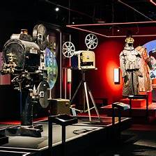
- Location: Gallery 1
- Focus:
  - Exploration of how advertisements influence consumer behavior
  - Analysis of persuasive techniques used in various media
- Activities:
  - Interactive engagement with exhibits demonstrating advertising strategies
  - Completion of structured observation tasks focusing on media codes and audience targeting
- Curriculum Links:
  - VCAMAR045: Analyze how representations, languages, and technologies create meaning in media artworks

11:00 AM – The Story of the Moving Image Exhibition
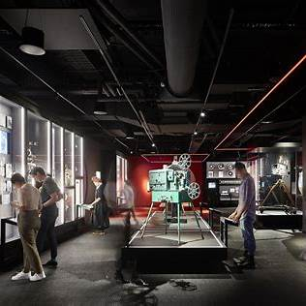
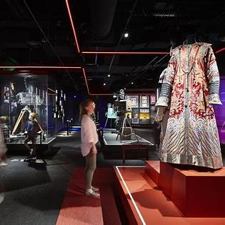
- Location: Gallery 1
- Focus:
  - Understanding the evolution of screen culture and its impact on society
  - Exploration of storytelling techniques across different media
- Activities:
  - Interaction with exhibits showcasing the history of film, television, and digital media
  - Participation in hands-on activities like the Foley Studio and Edit Line
- Curriculum Links:
  - VCAMAM042: Develop skills with media technologies to shape space, time, narrative, and points of view in images, sounds, and text.

12:00 PM – Lunch Break
- Location: Designated school group area
- Note: Students should bring their own packed lunch.

12:30 PM – Film It Workshop
- Location: ACMI Education Studio
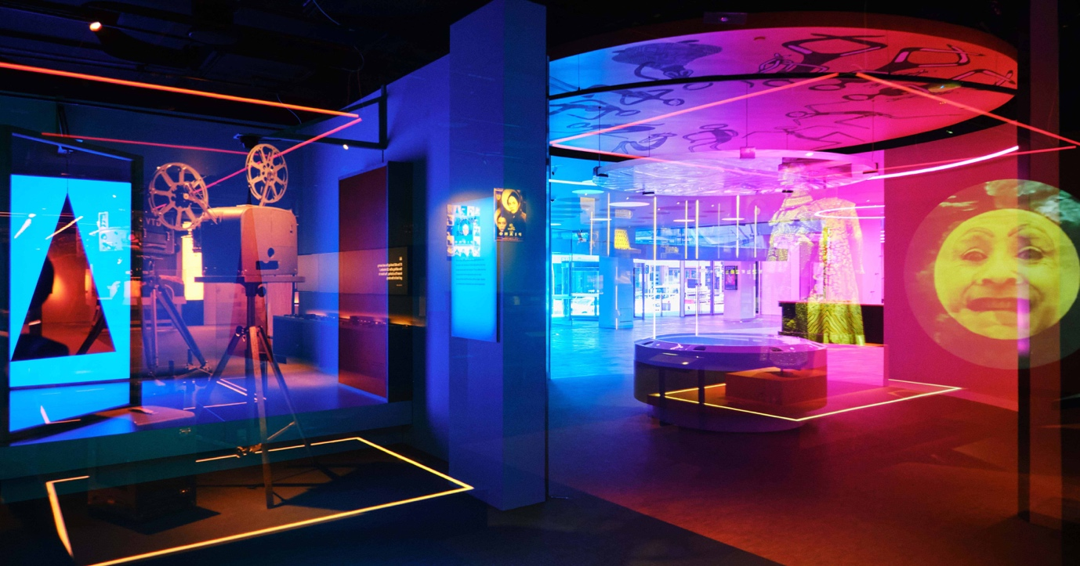

- Focus:
  - Hands-on experience in planning, filming, and editing a short advertisement
  - Application of media production techniques
- Activities:
  - Storyboarding and scripting an advertisement concept
  - Filming using provided equipment
  - Basic editing to produce a final advertisement piece
- Curriculum Links:
  - VCAMAP043: Plan, produce, and present media artworks for specific audiences and purposes using responsible media practices.

1:45 PM – Reflection & Debrief
- Location: ACMI Education Studio
- Activities:
  - Group discussion on key learnings from the day's activities
  - Completion of reflection prompts in the Media Reflection Journal
- Curriculum Links:
  - Personal & Social Capability: Reflect on how personal strengths can be used to achieve learning goals

2:15 PM – Departure
- Note: Ensure all personal belongings are collected and students are accounted for before departure.

