Teacher Checklist: Planning a Day Trip Excursion from Bendigo to ACMI, Melbourne
Planning a school excursion to the Australian Centre for the Moving Image (ACMI) in Melbourne involves several key steps to ensure student safety, educational value, and compliance with the Department of Education and Training (DET) Victoria guidelines. Below is a comprehensive guide to assist you in organizing a successful excursion.
Use the checklist to prepare and execute a successful and policy-compliant school excursion to ACMI. It outlines the ideal timeline for preparation, from early planning to the day before departure.

Timeframe | Key Actions
6–8 weeks before | - Define learning objectives and curriculum links  - Contact ACMI for available dates and program details  - Start risk assessment and venue evaluation  - Research transport options (e.g. chartered bus)
4–6 weeks before | - Submit excursion proposal to school principal www2.education.vic.gov.au+3www2.education.vic.gov.au+3www2.education.vic.gov.au+3  - Register in Student Activity Locator (SAL)  www2.education.vic.gov.au+1www2.education.vic.gov.au+1  - Confirm ACMI and transport bookings  - Send out parent consent and medical forms www2.education.vic.gov.au+2www2.education.vic.gov.au+2www2.education.vic.gov.au+2
2–3 weeks before | - Finalise staff and supervision (ensure first aid trained staff present)  Tip: Day excursions 1:20 staff-student ratio with a minimum of 2 staff  - Conduct student pre-excursion briefing  - Begin collecting signed consent and updated medical forms  - Schools may use the Template parent excursion consent form(DOCX).  - Electronic Consent: If using electronic methods, implement measures to verify the identity of the consenting parent or carer. www2.education.vic.gov.au
1 week before | - Organise emergency contacts, print risk assessments www2.education.vic.gov.au+7www2.education.vic.gov.au+7education.vic.gov.au+7  - Confirm details with ACMI and transport provider  - Prepare and organise printed materials and student info folders  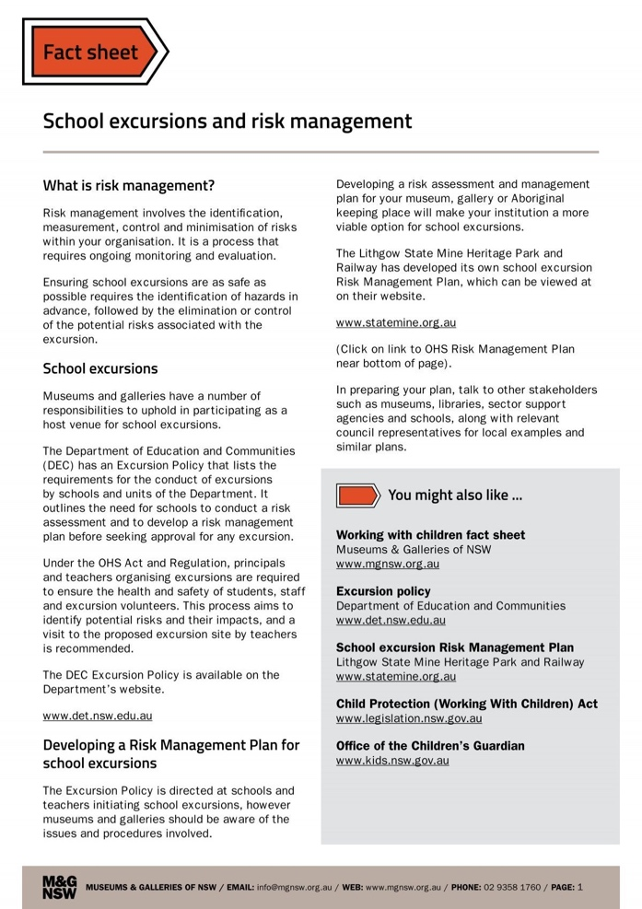  For example;  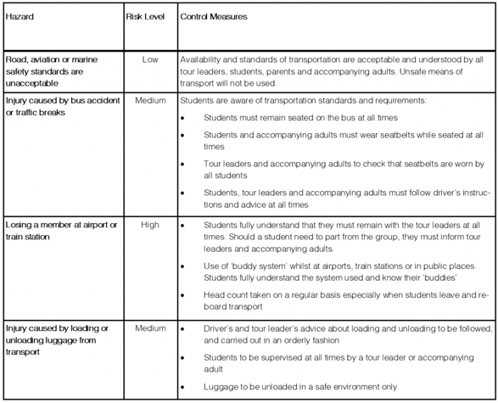
Day before | - Check and pack first aid kits  - Print all final documents and emergency contact lists  - Remind students of behaviour expectations and excursion logistics  www2.education.vic.gov.au

